Metro Ticket Generating System Using ServiceNow

Introduction :
Urban metro transportation has become one of the most widely used public transport systems due to its speed, affordability, and convenience. However, traditional ticket booking methods often involve long queues, manual ticket issuance, cash handling, and delays during peak hours. These challenges reduce operational efficiency and affect passenger satisfaction.
To overcome these limitations, the Metro Ticket Generating System using ServiceNow was conceptualized. The idea focuses on providing passengers with a seamless digital platform for booking metro tickets, calculating fares automatically, and generating QR code-based tickets through ServiceNow's Service Catalog and automation capabilities.
Brainstorming Objective :
The objective of this brainstorming session was to identify real-world problems in metro ticket booking and explore digital solutions that could be implemented using the ServiceNow platform.
The team discussed:
- Existing challenges in metro ticket booking.
- Passenger expectations.
- Automation opportunities.
- Security considerations.
- Future scalability.
Identified Problems :
During brainstorming, the following issues were identified:
- Long waiting queues at metro ticket counters.
- Manual fare calculation leading to errors.
- Time-consuming ticket issuance process.
- Dependence on cash payments.
- Lack of digital ticket storage.
- Difficulty in maintaining booking records.
- Limited visibility of passenger data for metro administrators.
- High operational workload during peak hours.

Proposed Ideas :
Several possible solutions were discussed before finalizing the project.
Idea 1: Mobile-Based Ticket Booking
Passengers can book metro tickets online instead of waiting at ticket counters.
Idea 2: Automated Fare Calculation
The system automatically calculates the ticket fare based on:
- Starting Station
- Destination Station
- Journey Type
- Number of Passengers
Idea 3: QR Code-Based Digital Ticket
After successful booking, a QR code is generated that can be scanned at metro entry gates.
Idea 4: Digital Payment Support
Provide support for multiple payment methods to encourage cashless transactions.
Idea 5: ServiceNow Automation
Use ServiceNow Flow Designer to automate ticket processing, database updates, and record management.
Idea 6: Secure Data Management
Store booking details in a custom Metro Database while restricting unauthorized access through Access Control Lists (ACLs).

Final Selected Idea :
The team selected the Metro Ticket Generating System using ServiceNow because it effectively addresses the identified challenges by automating ticket booking, fare calculation, QR code generation, and record management.
The solution leverages ServiceNow components such as:
- Service Catalog
- Custom Tables
- Catalog Client Scripts
- Flow Designer
- UI Policies
- ACLs
- Service Portal
to deliver a centralized, secure, and scalable metro ticketing application.

Figure 1.1 – Brainstorming Mind Map
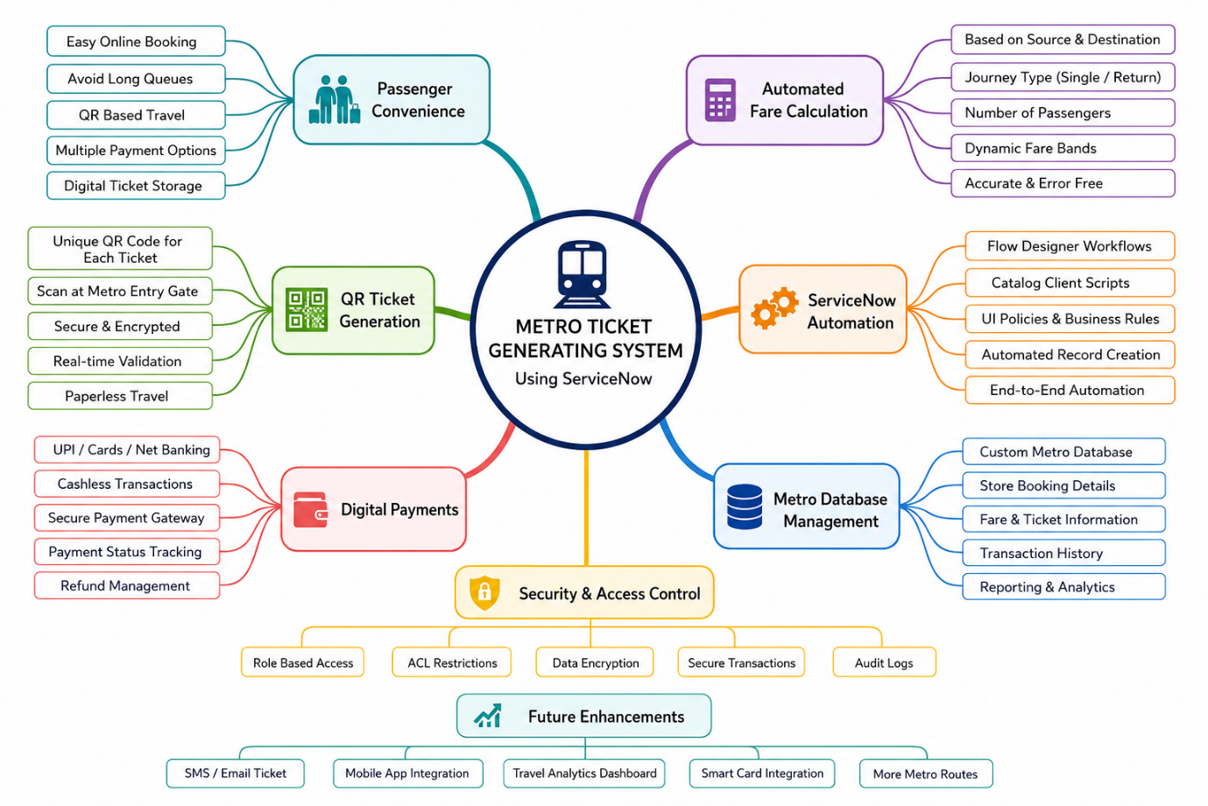

Central Idea
- Metro Ticket Generating System
Branches
- Passenger Convenience
- QR Ticket Generation
- Automated Fare Calculation
- ServiceNow Automation
- Digital Payments
- Data Security
- Metro Database
- Future Enhancements (SMS, Email Tickets, Analytics Dashboard.

